- First create a Maven Project. Go to File > New > Maven Project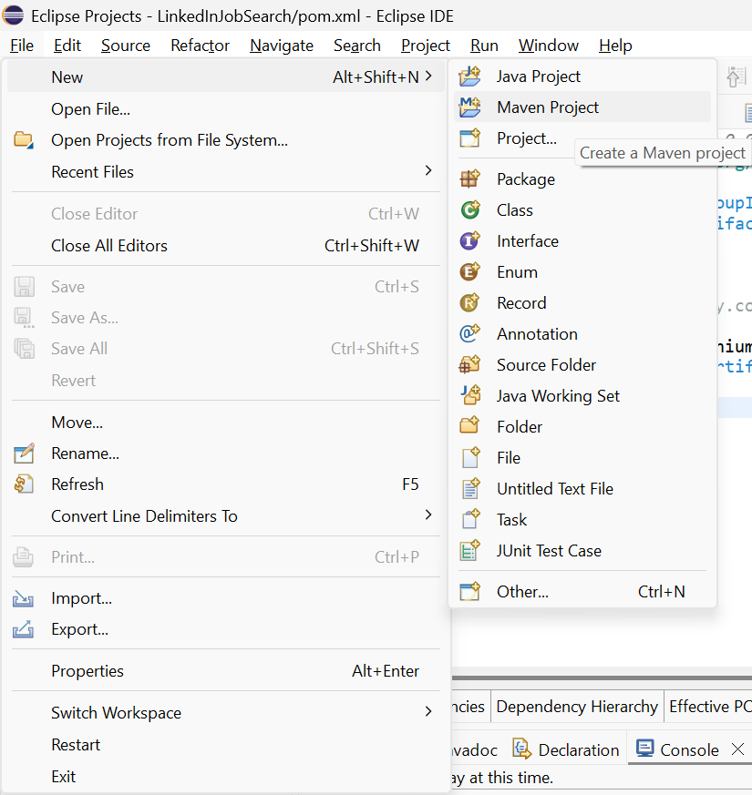

- Click on Create a simple project (skip archetype selection) check-box * and click on Next.
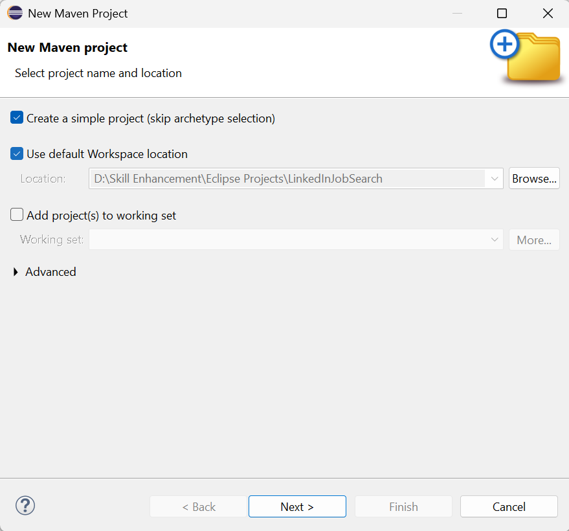
- Now your Group Id should always start with com. Or ends with .com and any name you want. The Artifact Id: should be your Project Name and click on Finish.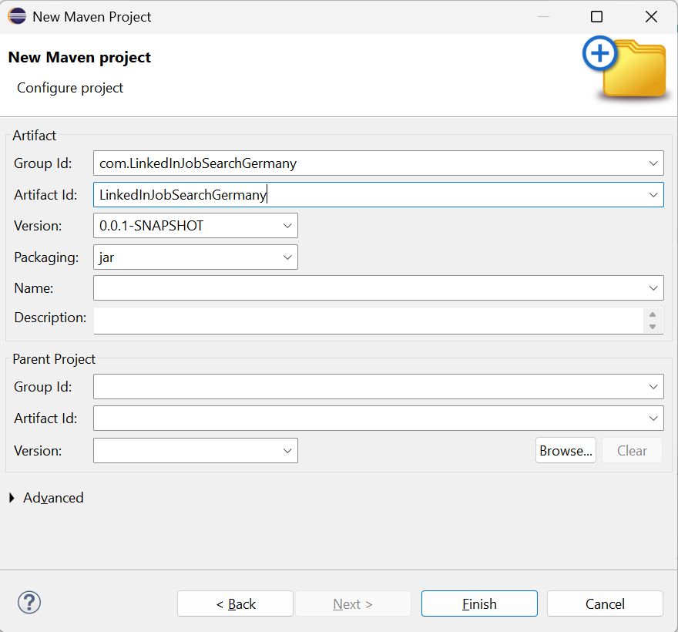

- Go to Maven Dependencies and search for latest version of Selenium Dependency at following URL: https://mvnrepository.com/artifact/org.seleniumhq.selenium/selenium-java/
- Copy the Dependencies and paste it in your POM File: 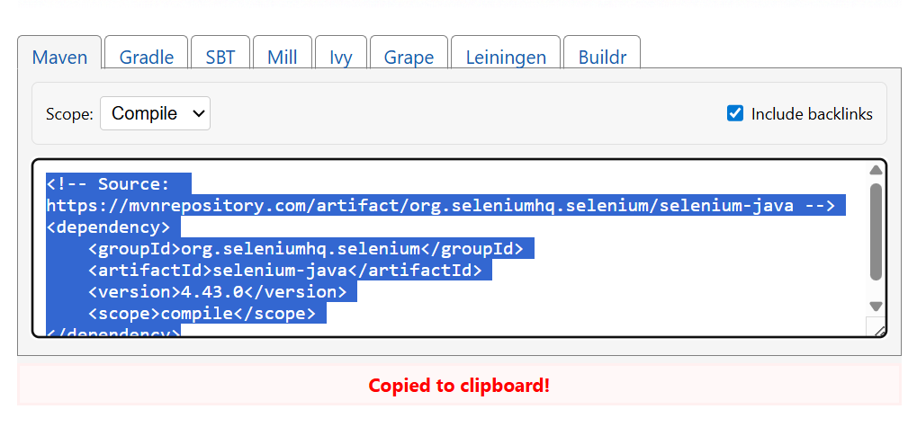
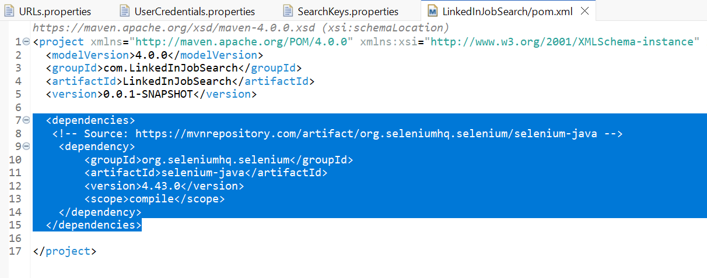

- Now go to Selenium Downloads with the link: https://www.selenium.dev/downloads/ and download Stable version of Selenium WebDriver for Java/Python as per your choice. 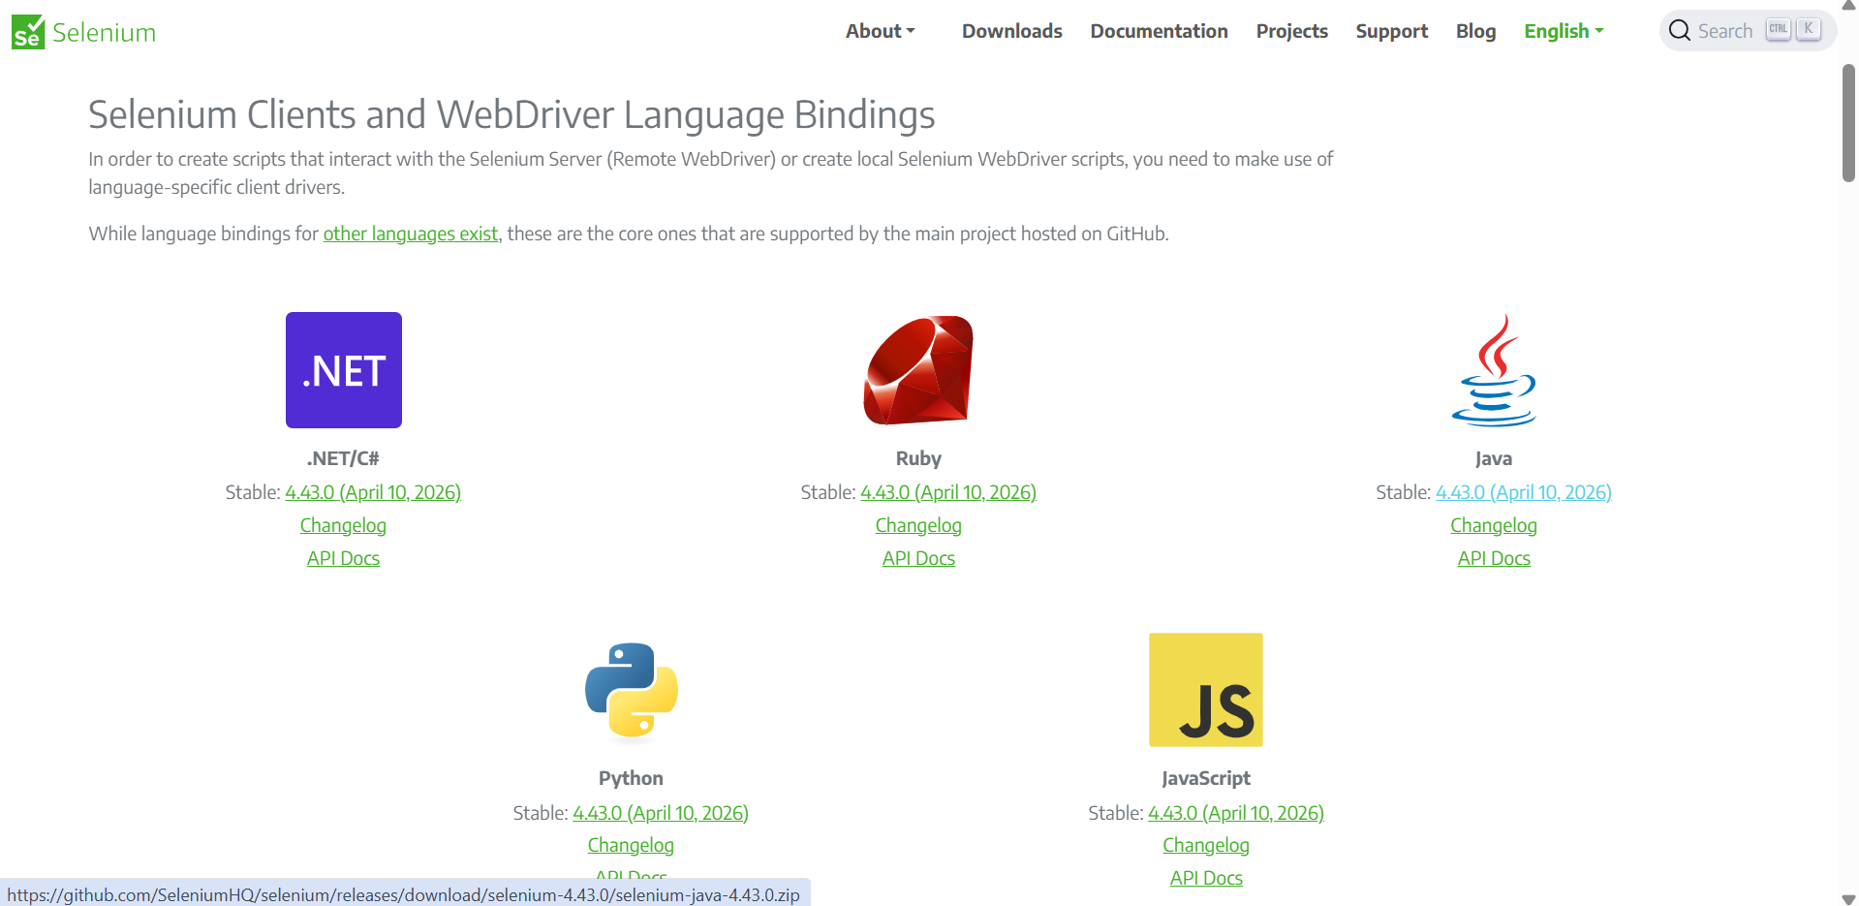
- The downloaded folder contains Selenium jar files and looks like this: 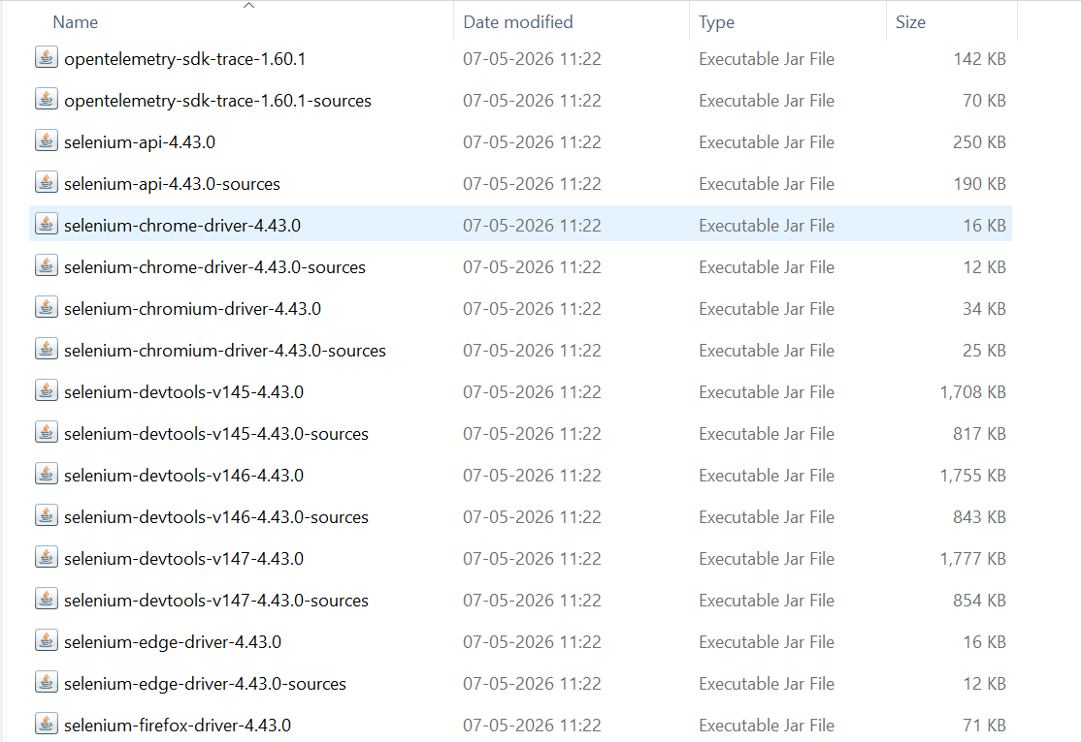

- In other way, you can download the latest stable version of Selenium Server (Grid) JAR file. This single file can be used to add all the dependencies of Selenium with Java. 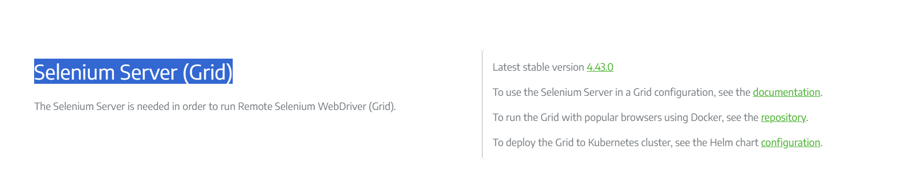 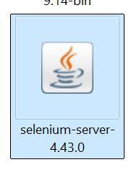
- Now add this jar file with your Build Path in Eclipse Maven Project.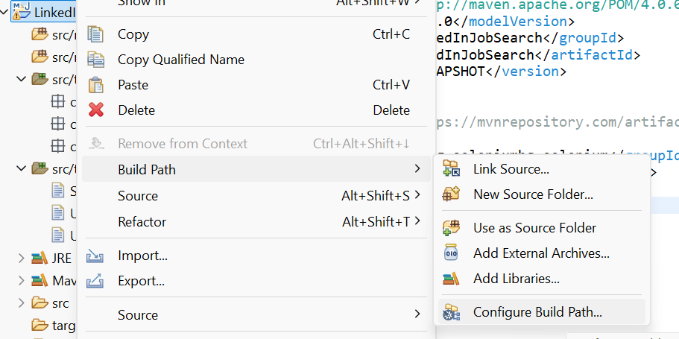
- Click on Add External JARs.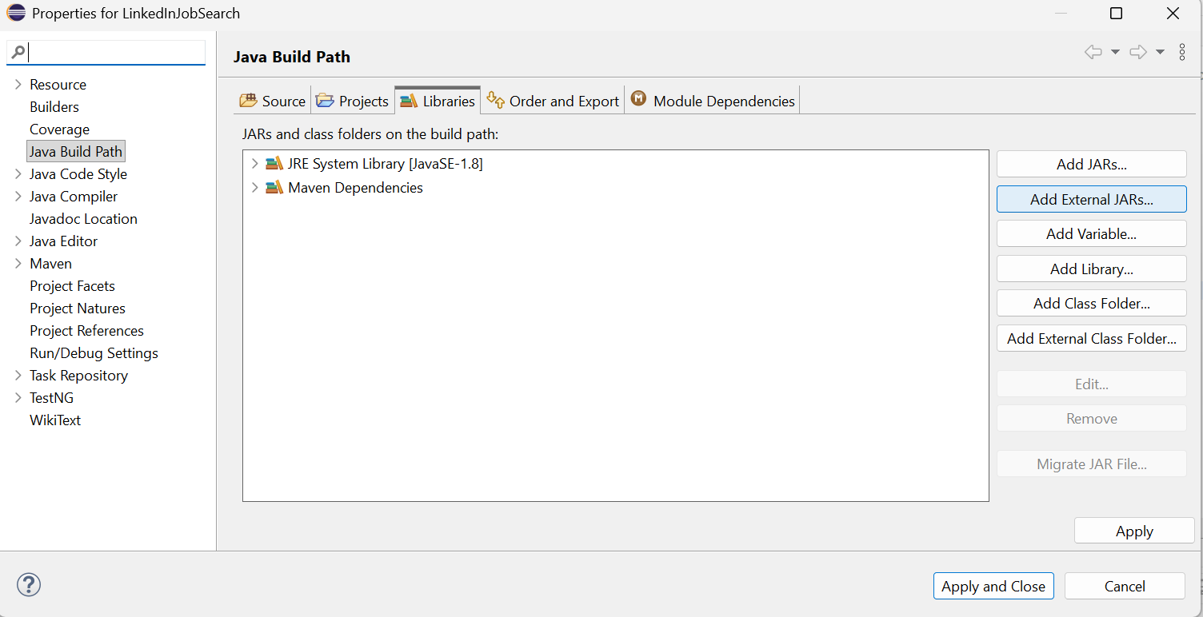
- Go to location where you have kept the downloaded JAR file(s) and click on Open. 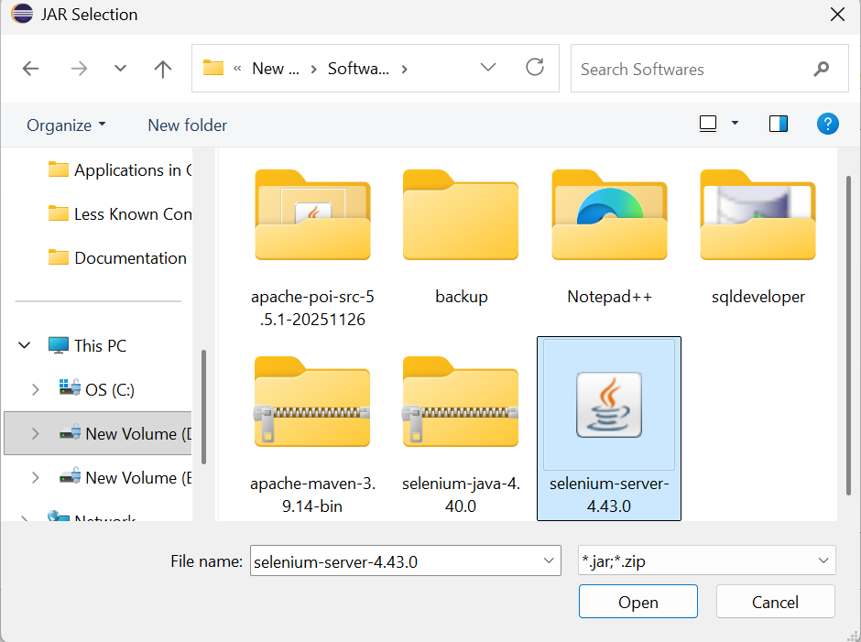
- Now simply click on Apply and Close: 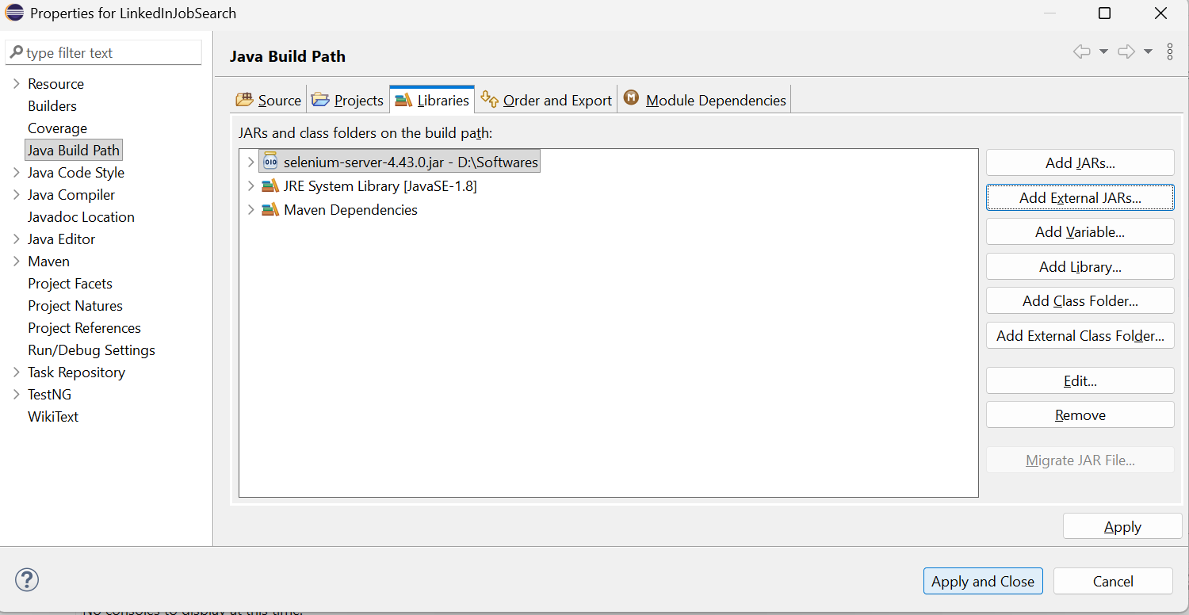
- Under your Reference Libraries in Maven Project, the added JAR file must be visible. 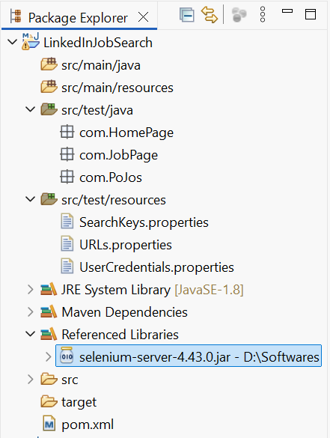

- Now to run your Selenium Code smoothly, you have to download the driver specific binary/exe file. Here we will take a sample of ChromeDriver.exe file. Go to the URL: https://googlechromelabs.github.io/chrome-for-testing/ and download latest stable version. 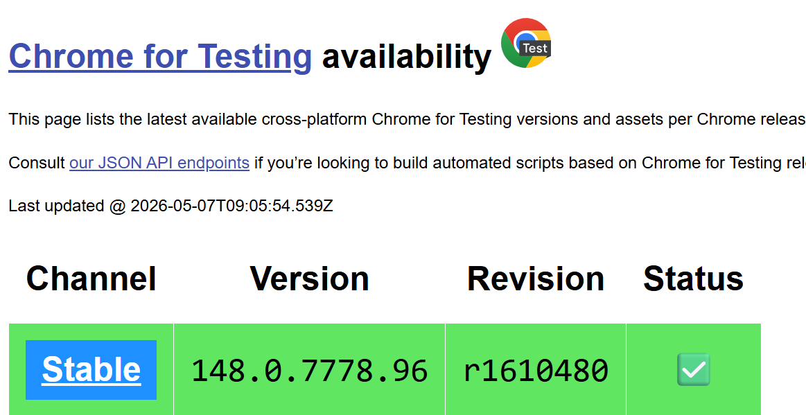

- Now select the stable version link and copy-paste it in your browser. It will download the zip file.

- Extract that Zip file and you will get your ChromeDriver exe file. Copy the file path and use it to setup your ChromeDriver in code.
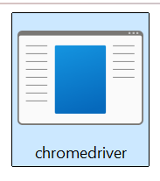
- Lastly, even after you follow everything correctly, and you are getting an error- org.openqa.selenium.devtools.CdpVersionFinder findNearestMatch
WARNING: Unable to find an exact match for CDP version 148, returning the closest version; found: 147; Please update to a Selenium version that supports CDP version 148
org.openqa.selenium.InvalidArgumentException: invalid argument
(Session info: chrome=148.0.7778.97)
Build info: version: '4.43.0', revision: 'dd0f534'
System info: os.name: 'Windows 11', os.arch: 'amd64', os.version: '10.0', java.version: '21.0.9'
Driver info: org.openqa.selenium.chrome.ChromeDriver
In such cases, add the WebDriverManager in your POM.XML file:
<!-- Source: https://mvnrepository.com/artifact/com.github.bonigarcia/webdrivermanager -->
<dependency>
<groupId>io.github.bonigarcia</groupId>
<artifactId>webdrivermanager</artifactId>
<version>5.5.3</version>
<scope>compile</scope>
</dependency>
- Finally add the setup line of code in your Java Class as per the driver you want to use. WebDriverManager.chromedriver().setup();
WebDriverManager.firefoxdriver().setup();
WebDriverManager.edgedriver().setup();
WebDriverManager.operadriver().setup();
WebDriverManager.iedriver().setup();
WebDriverManager.chromiumdriver().setup();

